LOCATION : NATIONWIDE
DATE : 07.07.2017
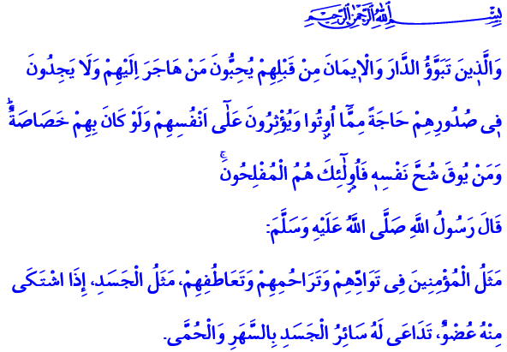
THE TEST OF OUR FAITH AND HUMANITY:
THE REFUGEES
Honorable Believers!
Helpers in Medina (the Ansar) embraced their emigrant brothers and sisters from Mecca (the Muhajirin) with love and sincerity, who left their estates and homeland behind and came to them for refuge. The helpers did not refrain from any sacrifice. Such an case happened when one of the helpers took a poor emigrant that our Prophet (pbuh) asked if any of the helpers could entertain as a guest. But he had nothing at home except the meal of his children. So he and his wife let their children sleep and then offered all the meal they had to their guest. They even found an excuse to put out the lamp and pretended to eat. They slept hungry that night, just like their children. After that, our Almighty Lord revealed this verse that praises the generosity of the helpers through them: “But those who before them, had homes (in Medina) and had adopted the Faith, show their affection to such as came to them for refuge, and entertain no desire in their hearts for things given to the (latter), but give them preference over themselves, even though poverty was their (own lot). And those saved from the covetousness of their own souls, they are the ones that achieve prosperity.”
Esteemed Muslims!
All thanks be to our Almighty Lord, our honorable nation, who followed the guidance of the Messenger of Allah and took this first generation of Muslims as role models, have become the Ansar to the Muhajirin for centuries. They opened their hearts without an ounce of doubt to those who came to them for refuge, regardless of their race, language or religion. They took the downtrodden and oppressed under their wings, no matter where they are. They looked after the orphans and the weak. They lent a hand to the poor and the needy. They have always been on the side of what is right and true, and stood by the righteous. They took a firm stand against oppression and the oppressors. And therefore, the poor and the lowly pray to Allah for our people with tears in their eyes and these prayers have become the never-ending power, the invincible shield of our nation. Our Lord have never let us become dishonorable, but made us honorable for the sake of these prayers that rise from these suffering hearts, for the sake of the hopes that find their way into the hearts of these deprived souls.
He never left us powerless, helpless and alone. He never denied us His help and grace.
Brothers and Sisters!
This land we live in have always been a home for the emigrants. This noble nation famous for their generosity and altruism have always been a safe haven. In recent years, millions of our brothers and sisters who escaped from the civil war, violence and massacres that take place in the region had to take refuge in our country. With a generosity that the whole world could only envy, our nation have extended a helping hand to these people and welcomed them in the best possible way.
But lately, we have sadly witnessed some unpleasant events that could cast a shadow upon the generosity of our nation. Especially, a perception management operation targeting our fellowship and hospitality is being carried out by certain groups. They are trying to incite grudge and hatred and harm the solidarity, unity, fondness and tranquility of our nation by spreading unfounded claims and messages on social media. All Muslim sisters and brothers must be alert and have foresight on this matter.
Dear Muslims in the Mosque!
As our Prophet (pbuh) said: “The parable of the believers in their affection, mercy, and compassion for each other is that of a body. When any limb aches, the whole body reacts with fever.” So come! Let us see our guests not as a burden but as a means of Allah’s grace. Let us not blame others for the mistakes of a few. Let us pray “Our Almighty Lord, please test no person and no nation with such a heavy trial!”
Let us not forget that insight, foresight and common sense are the values we need the most and that could support us in this hard time we are going through as a nation. We should acknowledge that our fellowship, solidarity, peace and tranquility are entrusted to us. Each soul that asks four our compassion and expects our help is a test of our faith, our Islam, and humanity.
Honorable Brothers and Sisters!
We are going to reach the first anniversary of the heinous coup that targeted the values and very existence of our nation on 15 July. Therefore, the Quran is being read in its entirety throughout the country, dedicated first to the souls of the martyrs of 15 July and then to the souls of all our martyrs. Also, there will be commemorations for our martyrs in every mosque and prayers will be made. We ask you to say “amin” to the prayers as an indication of our fidelity towards our martyrs. We once again ask mercy and grace for the martyrs that turned these lands into our homeland with their lives and ask swift recovery for the veterans from our Almighty Lord.

Al-Hashr, 59/9; Bukhari, Merits of the Helpers in Madinah, 10.
Bukhari, Al-Adab, 27. Written by: General Directorate of Religious Services

